Name:______________________
Date:_______________________
Period:______________________

“Rikki-tikki-tavi”
by Rudyard Kipling

Reading Guide

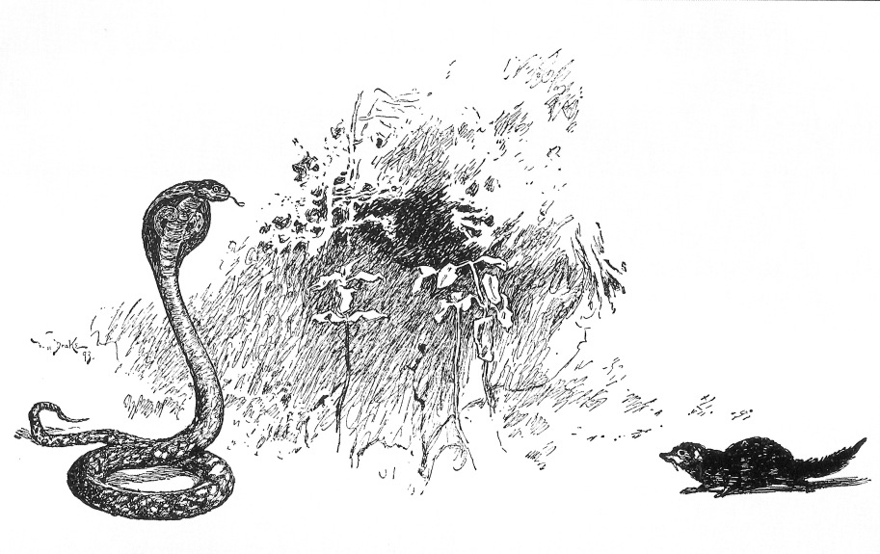
Event | Predictions | What Actually Happens
1. Teddy’s parents see Rikki-tikki on Teddy’s pillow.
2. Rikki-tikki meets Nag in the garden.
3. Rikki-tikki meets Karait in the garden.
4. Nag sneaks into the house at night.
5. Darzee’s wife pretends to have a broken wing.
6. Rikki-tikki is pulled down into Nagaina’s hole.
Making Predictions
DIRECTIONS: As you read “Rikki-tikki-tavi,” pause after each event listed in the “Events” column to make a prediction. Write your prediction in the “Predictions” column. When you find out what actually happens, write it in the “What Actually Happens” column.

Literary Elements: Plot Map
DIRECTIONS: As you read “Rikki-tikki-tavi,” record all important events of the story on this plot map.

Continued on next page
Main Characters
Major Conflict
Rising Action (list by numbered order)

Climax

Resolution
Falling Action (list by numbered order)
Animal’s Name | Type of Animal | Personality Traits | Key Actions or Words
Rikki-tikki-tavi | Mongoose | Confident, curious, brave, clever | Fights all snakes, plots to kill cobras, protects family.
Darzee
Darzee’s Wife
Chuchundra
Nag
Nagaina
Name:________________________
Date:_______________
Period:_____
Literary Devices: Personification
DIRECTIONS: In the story, Kipling personifies, or gives human traits to, animals. As you read, complete the chart below. Identify the type of animal each character is, the animal’s traits, and the key actions or words you used to find those traits.
Name:________________________
Date:_______________
Period:_____
Reading Comprehension Questions
DIRECTIONS: As you read “Rikki-tikki-tavi,” answer the following questions on a blank sheet of paper. Add you NDP to any additional pages and staple them to your packet.

- SECTION A
1. Kipling reveals the setting of the novel slowly as the story progresses. List at least five facts about the setting of this story.
2. What does Rikki-tikki-tavi say is the motto of the mongoose family, and how does he follow this motto and show that he is a true mongoose?
3. Why are Darzee and Darzee’s wife so sad when Rikki-tikki first meets them?
4. Briefly describe Rikki-tikki’s first meeting with Nag and Nagaina.
- SECTION B
1. How did Rikki-tikki first become a hero, and how was he treated after his encounter with Karait?
2. Who warns Rikki-tikki of Nag and Nagaina’s plan and how is this creature characterized by Kipling?
3. Briefly describe the events that led up to Nag’s death.
4. Why does Rikki-tikki need to find Nagaina’s nest, and why do you think Darzee is reluctant to help him?
5. How does Rikki-tikki make sure that Nagaina is distracted long enough for him to find her nest? Does this diversion work?
- SECTION C
1. Rikki-tikki destroys Nag and Nagaina’s eggs, even though he was appalled that Nag ate one of Darzee’s fledglings. Are Rikki-tikki’s actions justified, or is he being a hypocrite?
2. How does Rikki-tikki lure Nagaina away from the family?
3. Why is it so dangerous for Rikki-tikki to follow Nagaina into her hole? What do Rikki-tikki’s friends think will happen to him underground?
4. Rikki-tikki has killed Karait, Nag, and Nagaina, as well as Nagaina’s babies. Were Rikki-tikki’s actions justified, or was he just a murderer? Why do you think so?

Name:________________________
Date:_______________
Period:_____

A. “…and his war cry as he scuttled through the long grass was Rikk-tikk-tikki-tikki-tchk!”

B. “They had made a beautiful nest by pulling two big leaves together and stitching them up the edges with fibers and had filled the hollow with cotton and downy fluff.”

C. Karait said “Be careful. I am Death!”

D. “Chuchundra sat down and cried till the tears rolled off his whiskers. ‘I am a very poor man,’ he sobbed.”

E. “Darzee was a featherbrained fellow who could never hold more than one idea at a time in his head…”

F. “When a cobra runs for her life, she goes like a whiplash flicked across a horse’s neck.”

_____1. ONOMATOPOEIA

_____2. SIMILE

_____3. METAPHOR

______4. ALLITERATION

______5. IMAGERY

______6. PERSONIFICATION
Literary Devices: Adding Style
DIRECTIONS: Match the following literary devices to their examples from Rudyard Kipling’s “Rikki-tikki-tavi.”
Name:________________________
Date:_______________
Period:_____
“Rikki-tikki-tavi” Acrostic Poem And Literary Device Project
DIRECTIONS: Choose one of the following characters from Kipling’s short story, “Rikki-tikki-tavi” and compose an acrostic poem representing the character. Using correct acrostic poem format is not the only requirement of this project, however. You must also include examples of literary devices in your poem. See below for project requirements! (This project is worth 20 points)
- Step 1: Choose from the following characters:
  - Rikki-tikki-tavi
  - Darzee
  - Darzee’s Wife
  - Nag and Nagaina
  - Nagaina
  - Chuchundra

NOTE: If you would like to write your poem on Nag, you MUST use “Nag and Nagaina” because Nag is too short!

- Step 2: Using the story as inspiration, write an acrostic poem that displays your character’s personality and role in the story. Besides using the story as your inspiration, your poem MUST contain at least one example of each of the following literary devices.
  - Alliteration (UNDERLINE the first letters of the alliterative words in RED)
  - Simile (HIGHLIGHT your simile in YELLOW)
  - Metaphor (UNDERLINE your metaphor one time in BLUE)
  - Onomatopoeia (CIRCLE your onomatopoeia in PURPLE)
  - Imagery (Place a GREEN BOX around your example of imagery)
  - Personification (UNDERLINE your example of personification in BLACK)

    - You must use each literary device properly and LABEL it within your poem as specified by the directions in parentheses following each literary device!

- Step 3: Format your acrostic.
- The character’s name will be written vertically down the left side of the page.
- Your acrostic may be presented artistically on poster-board, or you may choose to type/print your project. If you do type your poem, the font style, color, and size are up to you.
- You may also choose to use appropriate and related clip art, original drawings, emoticons, etc. on your finished product to enhance your poem; but this is NOT a requirement!
Rikki-Tiki-Tavi: Example Acrostic Poem
Nag’s scheming spouse.
All creatures great and small fear her sharp hiss.
Grabbed her egg and fled for her life into her hole.
A cold-blooded killer.
Is as treacherous as snake-haired Medusa.
Not exactly the type of neighbor you’d want living next door.
At the end, she gets what she deserves!

